**LEBANESE AMERICAN UNIVERSITY**

**USAID – HIGHER EDUCATION SCHOLARSHIP PROGRAM**

**HES - Volunteering Program Verification Form**

This form is to be used to document volunteering hours. If a student volunteers for multiple organizations, a separate form must be used for each organization. **This form must be turned in by the 28th of each month, the latest.**

I certify that the scholar Clarita Rizk completed a total of 6 hours of service at Life Sculptor.

The hours were completed hours as per the below:

Hours # 0 (date) _02/09 - 06/09_ (initials of supervisor) __A.K.___

Hours # 2 (date) _09/09 – 13/09_ (initials of supervisor) __A.K.___

Hours # 4 date) _16/09 – 20/09 (initials of supervisor) __A.K.___

Hours # 0 date) _23/09 – 27/09 (initials of supervisor) __A.K.___

Brief description of the activities the scholar performed or participated in:

I designed 3 powerpoints : intro to cybersecurity, building a culture of innovation, and innovation through brainstorming .

Written feedback about the scholar’s performance:

Clarita has successfully designed three informative PowerPoint presentations on key topics: intro to cybersecurity, building a culture of innovation, and innovation through brainstorming. Her ability to present complex information clearly and engagingly reflects her dedication to enhancing our educational materials. Clarita's contributions are greatly valued.

Please rate the overall performance of the scholar at your organization:

|  |  |  |  |
| --- | --- | --- | --- |
|  | Mastery (5) | Proficient (3) | Emerging (1) |
| **Problem solver** | X |  |  |
| **Engaged & Committed** | X |  |  |
| **Open-minded & multicultural** | X |  |  |

Signature

& stamp

__________________________

_

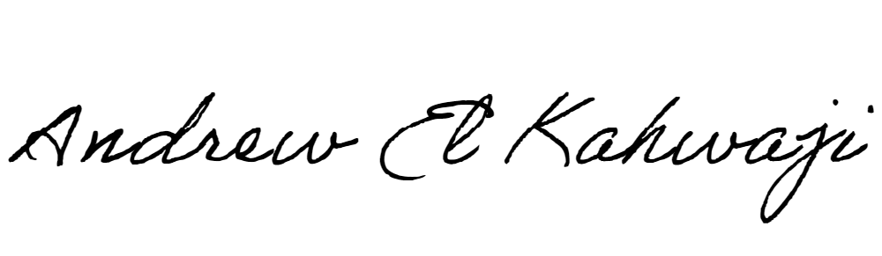

Printed Name _Andrew El Kahwaji_

Date __25/09/2024___

Email __andrew.lifesculptor.coo@gmail.com __

Phone __+961 71 914 378__

**LEBANESE AMERICAN UNIVERSITY**

**USAID – HIGHER EDUCATION SCHOLARSHIP PROGRAM**

